**KENDRIYA VIDYALAYA**

**IIT CAMPUS CHENNAI**



**COMPUTER SCIENCE**

PROJECT

2020-21

TOPIC: CHESS

**NAME: Dharshan S**

**CLASS/SEC:** **XII-B**

**CBSE REGISTRATION NO:**

**CERTIFICATE**

This is to Certify that Dharshan S, student of class XI – B has successfully completed the below mentioned under the guidance of SNS Kalyan Bharadwaj B(computer science teacher) during the year 2020-2021 in partial fulfilment of computer science practical examination.

**INTERNAL EXAMINER**

**PRINCIPAL**

**ACKNOWLEDGEMENT**

*In the accomplishment of this project successfully, many people have best owned upon me their blessings and the heart pledged support, this time I am utilizing to thank all the people who have been concentrated with project.*

*Primarily I would thank god for being able to complete this project. Then I would like to thank my principal Dr. M.MANICKASWAMY and my computer science teacher SNS KALYAN BHARADWAJ B whose valuable guidance has been the ones that helped me patch this project and make it full proof success his suggestions and his instructions has served as the major contributor towards the completion of the project.*

*Then I would like to thank my parents and my lovable friends who helped me with their valuable suggestions and guidance has helped me in various phase of completion of project.*

**TABLE OF CONTENTS**

1. ABSTRACT
2. REQUIREMENTS
3. PROGRAM CODE
4. OUTPUT

**ABSTRACT**

In this Project ,we have created a Chess GUI program using Tkinter,

as well as used files to store the previous games and load them

**OUTPUT**

Opening Screen

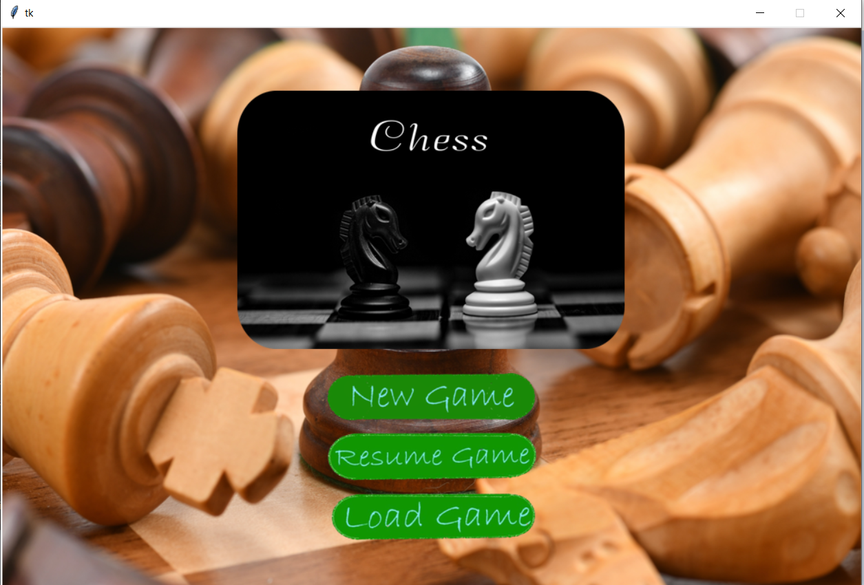

Loading a Previous game Screen 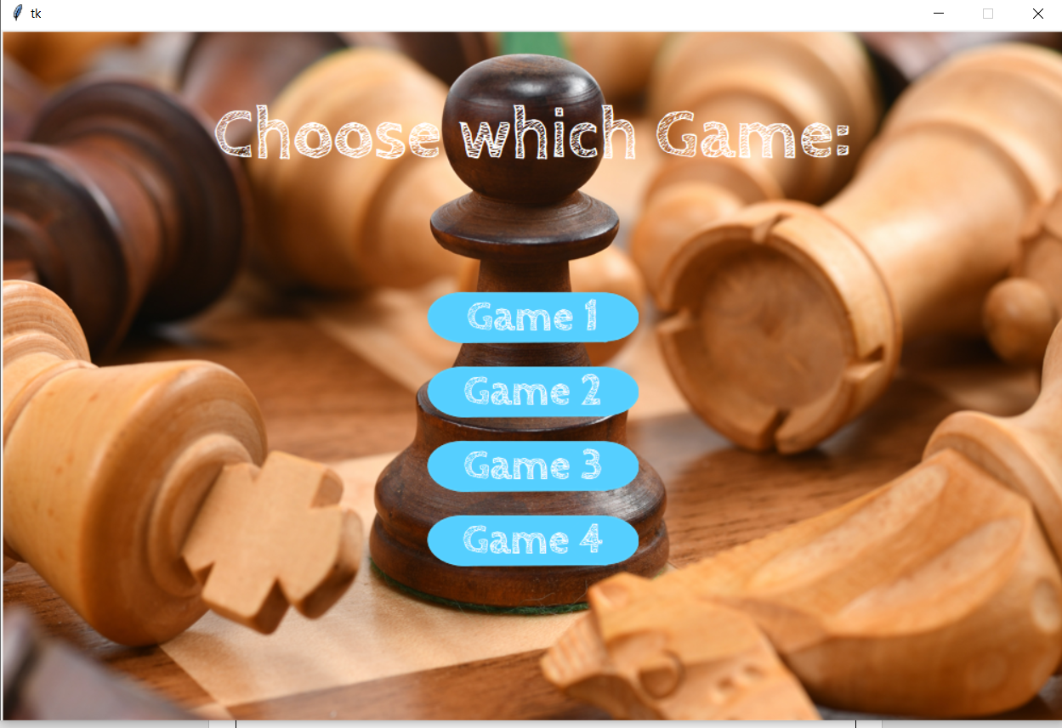

Check

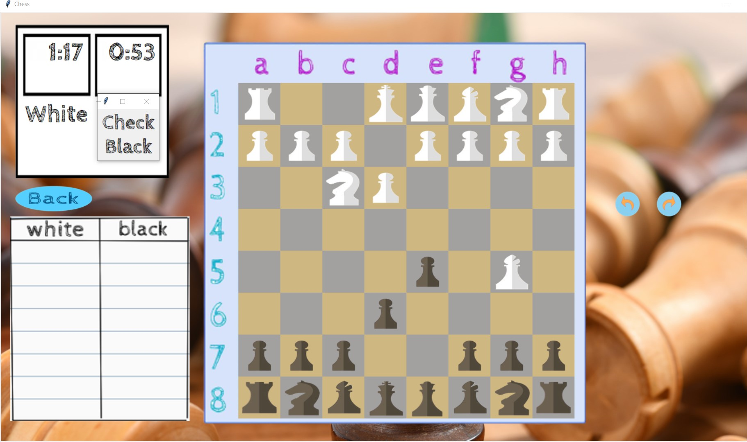

Moving during Check 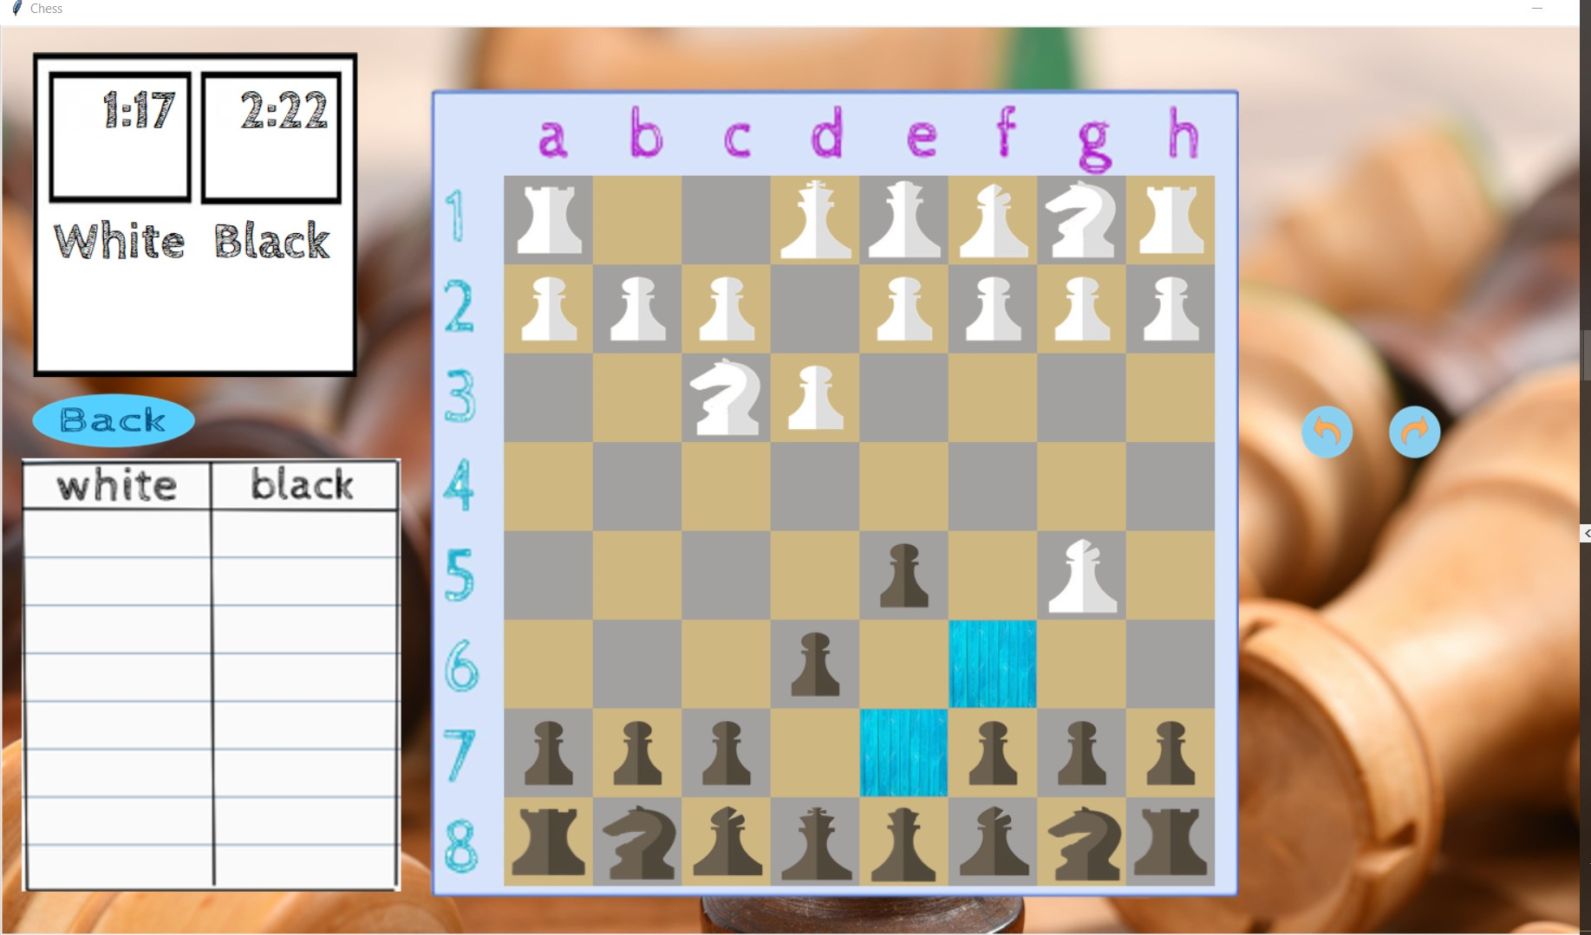

Regular Move

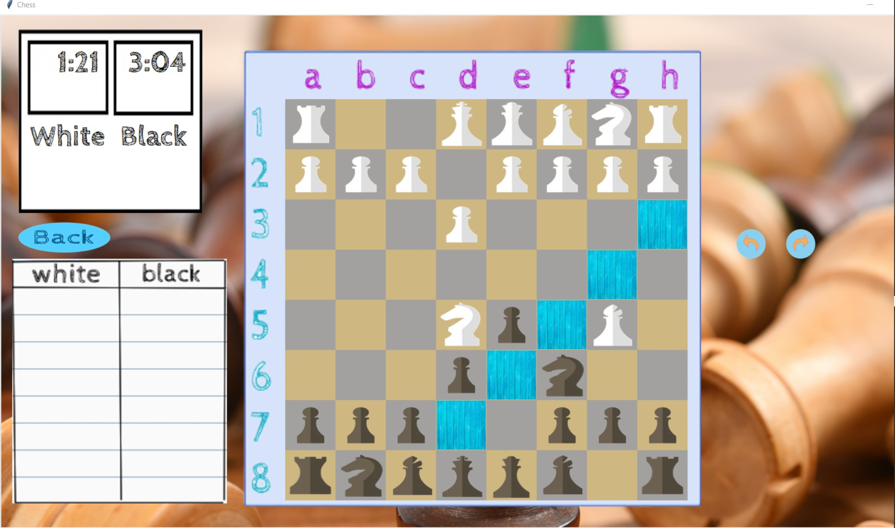

Pawn Changing Screen

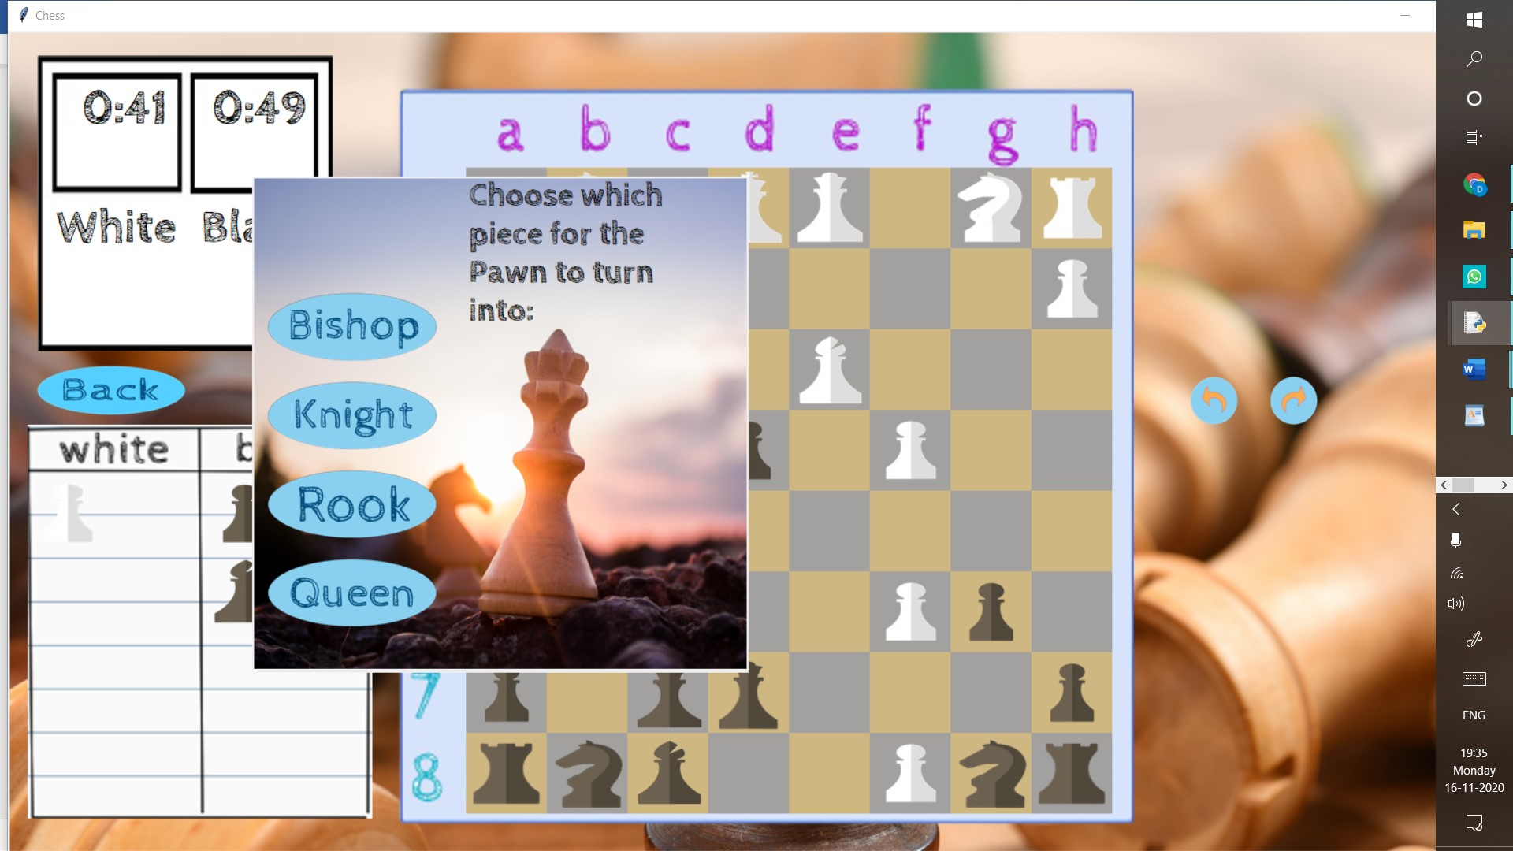

Pawn Changed

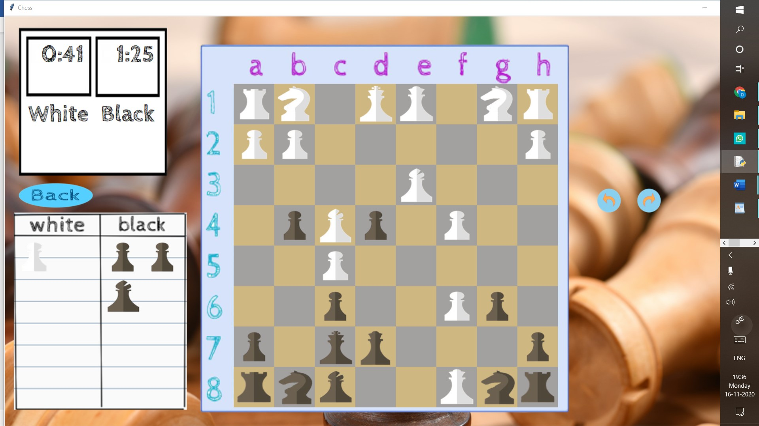

**Things to Improve on**

1)Castling

2)Checkmate

3)Particular moves

**REFERENCES**

1.<https://docs.python.org/3/tutorial/index.html>  
2.Computer Science with Python for Class 11, Sumit Arora

3.Various websites geeksforgeeks ,stackexchange,etc